**Getting Started**

**with CodeSpace**

**Student Workbook**



**Welcome to CodeSpace!**

You are about to start this exciting adventure into programming with Python!

You need to type your programs, or code, somewhere. Instead of using a Google Doc or Microsoft Word, you are going to use a special text editor called CodeSpace.

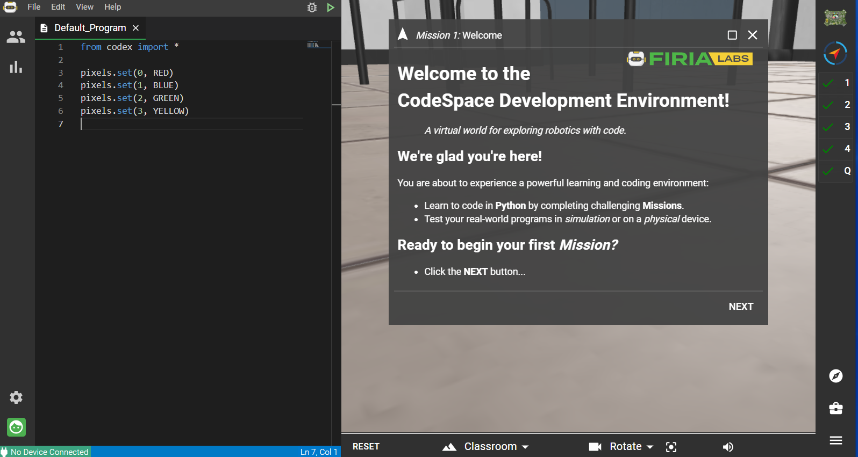

To use CodeSpace, you will create a free account and use a code from your teacher to join your class.

Don’t worry -- this is easy! All you need is an email.

Email I will use for my Firia Labs Missions:

__________________________________________________________________

**Getting started**

1. Open the Chrome browser on you computer / laptop / chromebook:

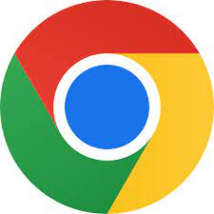

1. Use the link, or type <https://make.firialabs.com/>
2. Click the green LOG IN button

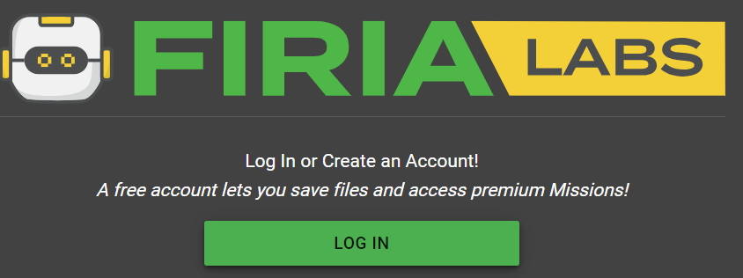

1. You can either create an account with your email address, and choose a password --OR-- if your email is GMail, click on “Sign in with Google”

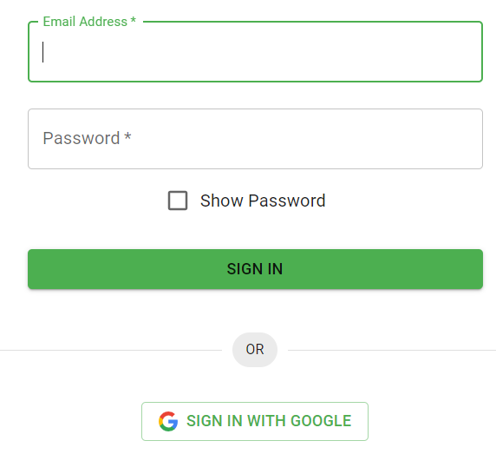

1. In CodeSpace, you can log in/log out with this icon (bottom left corner):

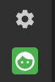

1. You will join your class by clicking here (upper left corner):



1. Now click “JOIN CLASS” (upper right corner):

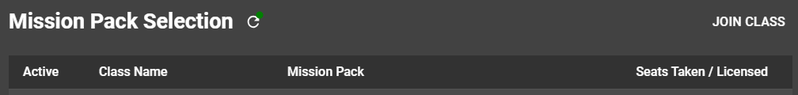

1. Enter the code your teacher gives you:

JOIN CODE (from teacher): ______________________________________

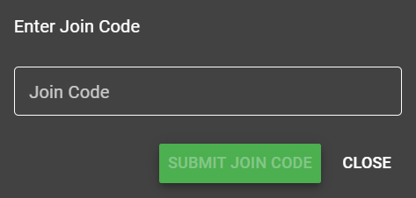

1. Click “SUBMIT JOIN CODE”

**All set!** 

Your course in Python is selected and you are ready to begin. You should see these icons in the upper right corner CodeSpace.

**Things to remember** 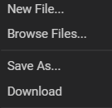

* Your program files are saved automatically, all the time, in the cloud
* Start a new program with “**New File…**”
* You can open earlier programs by going to “**Browse Files…**”
* If you want to make changes to a program, but keep the original code, “**Save As…**” with a new name
* You can download a text file of your code with “**Download**”

**Go to Mission 1 and get started!**